INDUSTRY PROBLEM SOLVING TASK
Computer Vision – Questions and Answers

1. Autonomous Vehicle Vision System Selection
Question: An automobile company is developing an autonomous vehicle detection system that must operate under the following conditions: if accuracy is below 90% the system fails; if latency is above 70 ms it is unacceptable; and the vehicle supports moderate computational resources. Compare the three methods and evaluate which method satisfies all the constraints. Justify your decision using logical reasoning based on accuracy, latency, and computational requirements.
Answer
An autonomous vehicle vision system must identify objects accurately and respond quickly because decisions have to be made while the vehicle is moving. According to the given problem, the system cannot accept an accuracy below 90% and cannot tolerate latency greater than 70 ms. In addition, the vehicle can provide only moderate computational resources. These three conditions form the basis for selecting the most suitable method.
Viola-Jones has an accuracy of 82%, latency of 30 ms, and low computational requirements. Its low latency is an advantage because it can process information quickly. However, the accuracy is below the required 90%. Since the problem explicitly states that accuracy below 90% causes system failure, Viola-Jones cannot be selected even though it is fast and computationally efficient.
Deep Learning achieves 97% accuracy, which is excellent and comfortably above the required threshold. However, its latency is 90 ms, which is higher than the maximum permitted 70 ms. It also requires high computational resources, while the vehicle supports only moderate computation. Therefore, Deep Learning violates two important deployment constraints.
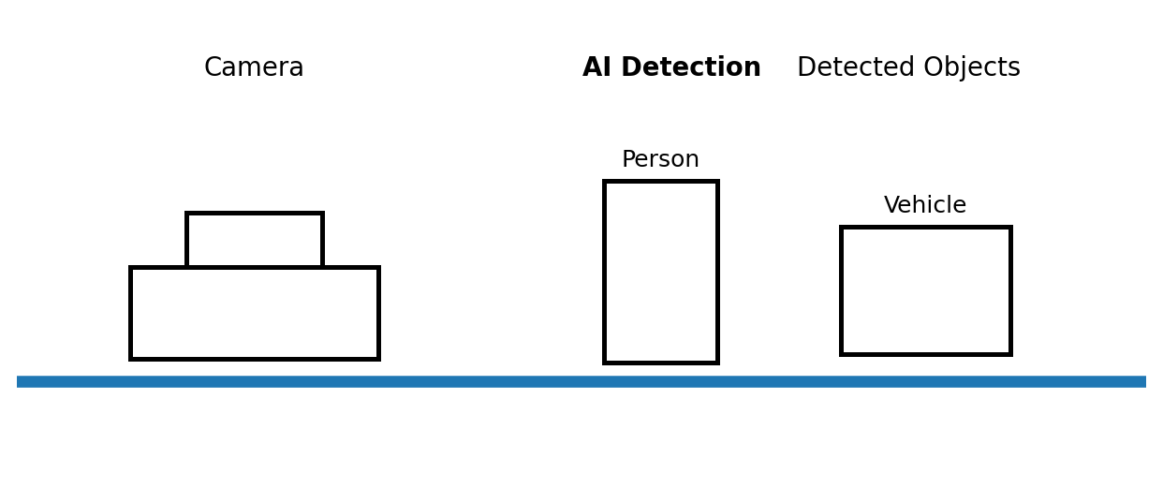
Figure 1: Conceptual view of real-time vision-based object detection in an autonomous vehicle.

1. Autonomous Vehicle Vision System Selection – Continued
YOLO provides 93% accuracy, 60 ms latency, and moderate computational requirements. Its accuracy is above the required 90% threshold, and its latency remains below the maximum 70 ms limit. Most importantly, its computational requirement is moderate, which matches the resources available in the vehicle.
When the three methods are considered logically, Viola-Jones fails because its accuracy is too low. Deep Learning fails because its latency is too high and its computational requirement is beyond the stated hardware capability. YOLO is the only method that satisfies accuracy, latency, and computational requirements simultaneously.
The selection of YOLO is therefore not based only on its accuracy. Deep Learning has higher accuracy, but that additional accuracy cannot compensate for unacceptable latency and excessive computational requirements. Similarly, the faster Viola-Jones method cannot be chosen because its accuracy does not reach the required level.
For an autonomous vehicle, a balanced method is important because the system must provide sufficiently accurate object detection while responding within a limited time. YOLO offers this balance with 93% accuracy and 60 ms latency while requiring moderate computation.
Therefore, YOLO is the most appropriate method for the specified autonomous vehicle vision system. It satisfies every stated constraint and provides a practical balance between detection quality, response time, and computational demand.
Final decision: YOLO should be selected because it is the only available method that meets all the requirements given in the problem.

2. Smart Factory Product Inspection Selection
Question: A manufacturing company wants to deploy a real-time computer vision system to detect defective products on a production line. If accuracy is below 95% defects may be missed; if processing time is above 50 ms production is affected; and the hardware supports moderate computation. Compare the three methods and evaluate which method satisfies all the constraints. Justify your decision using logical reasoning based on accuracy, processing time, and computational requirements.
Answer
A smart factory product inspection system must detect defective products accurately while keeping up with the speed of the production line. The given constraints require at least 95% accuracy, a processing time of no more than 50 ms, and moderate computational requirements. A method that fails any one of these conditions is not suitable for the specified deployment.
Traditional Image Analysis provides 91% accuracy, 25 ms processing time, and low computational requirements. Its processing time is very good and its low computational demand makes it easy to deploy. However, its accuracy is only 91%, which is below the required 95%. Because the problem states that lower accuracy may cause defects to be missed, this method cannot be selected.
Deep Learning provides the highest accuracy at 98%, which satisfies the accuracy requirement. However, its processing time is 75 ms, exceeding the allowed 50 ms. It also requires high computational resources, while the hardware is specified as supporting only moderate computation. Therefore, Deep Learning is not suitable despite its high accuracy.
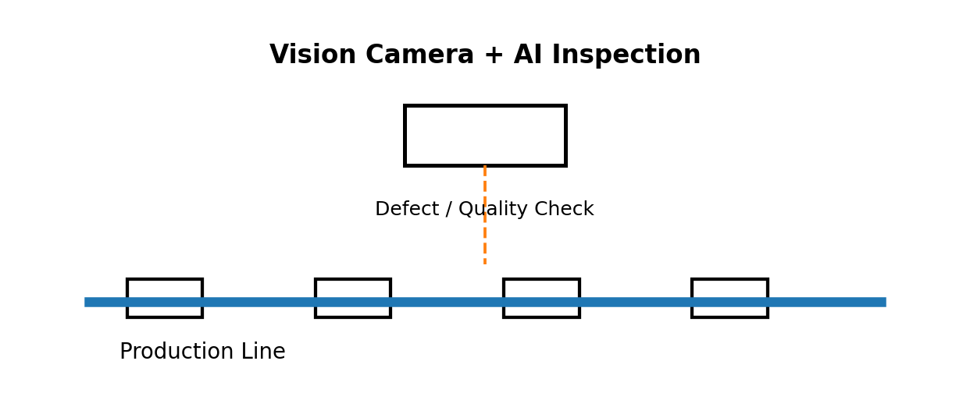
Figure 2: Conceptual AI-based visual inspection system on a smart factory production line.

2. Smart Factory Product Inspection Selection – Continued
YOLO provides 96% accuracy, 45 ms processing time, and moderate computational requirements. Its accuracy is above the required 95%, its processing time is below the 50 ms limit, and its moderate computational requirement matches the available hardware.
The three methods can therefore be evaluated logically. Traditional Image Analysis is fast and inexpensive in computation but fails the accuracy requirement. Deep Learning has excellent accuracy but fails the processing-time and computational requirements. YOLO is the only method that satisfies all three conditions at the same time.
In a production environment, processing time is particularly important because the inspection system must work continuously without slowing the manufacturing process. At the same time, the accuracy must be high enough to avoid missing defective products. YOLO provides an appropriate balance between these two needs.
The moderate computational requirement is another important reason for selecting YOLO. Since the hardware supports moderate computation, a method requiring high computation would not be a practical choice even if its accuracy were higher.
Therefore, YOLO should be selected for the smart factory product inspection system. It achieves 96% accuracy, completes processing within 45 ms, and requires moderate computation. It is consequently the only method among the three that satisfies every condition stated in the problem.
Overall Conclusion
Both industry problems lead to the same final selection: YOLO. In the autonomous vehicle problem, YOLO satisfies the 90% minimum accuracy, 70 ms maximum latency, and moderate-computation requirements. In the smart factory problem, it satisfies the 95% minimum accuracy, 50 ms maximum processing-time, and moderate-computation requirements. Thus, YOLO provides the required balance between accuracy, speed, and practical deployment resources in both applications.

